
Data Flow Diagram
Date | 30 SEPT 2026
Team ID | SWTID-2026-9948
Project Name | EduGenie – AI Learning Assistant
Maximum Marks | 2 Marks

Data Flow Diagram
The Data Flow Diagram illustrates how EduGenie processes educational queries, generates AI responses, and stores learning history.

DFD Symbol Legend
Symbol | Name | Description
Oval | External Entity | User
Rectangle | Process | AI Processing Module
Database | Data Store | SQLite Database
Arrow | Data Flow | Information exchange


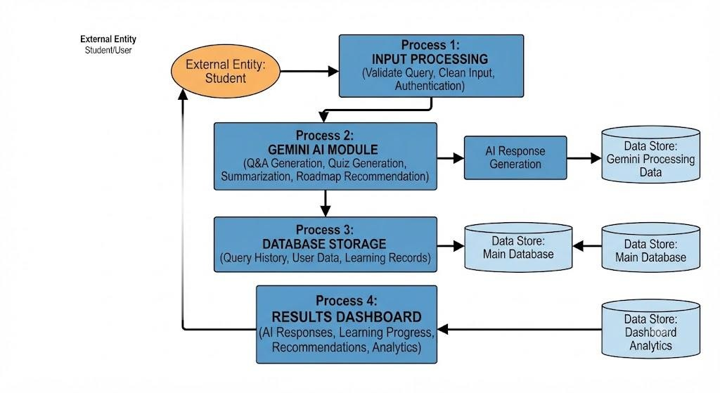
Page 1

